

**BFA Animation & VFX**

**Batch 2014-17**

**First & Second Semester**

**Detailed Syllabus**

**Department of Computer Applications**

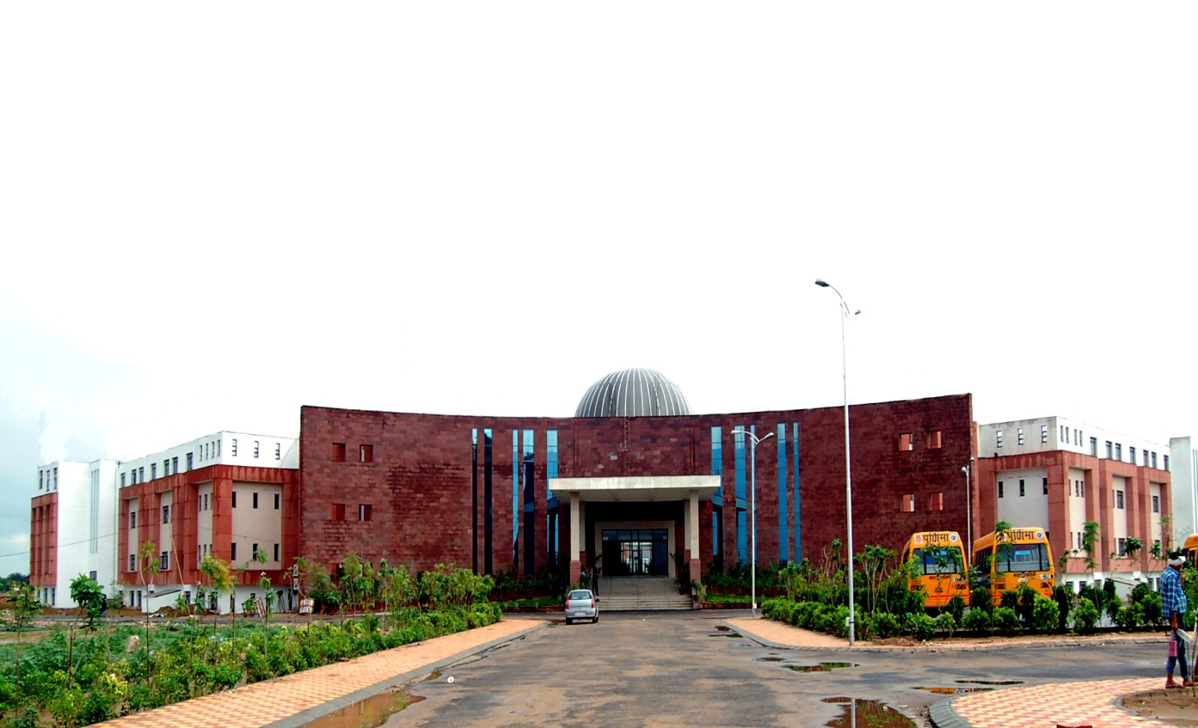

**SCHOOL OF BASIC & APPLIED SCIENCES**

|  |  |  |  |  |  |
| --- | --- | --- | --- | --- | --- |
| **POORNIMA UNIVERSITY** | | | | | |
| **Bachelor of Fine Arts – Animation & VFX(Batch 2014-17)** | | | | | |
| **First Year - First Semester** | | | | | |
| **Subject Code** | **Subject Name** | **Teaching Scheme (Hrs per week)** | | | **Credits** |
| **Lec (L)** | **Tut (T)** | **Prac (P)** |
| **A.** | **Core Subjects (Theory)** |  |  |  |  |
| BFA01101 | English I | 2 |  |  | 2 |
| BFA01102 | Office Automation tools | 4 |  |  | 4 |
| BFA01103 | Animation Principles | 4 |  |  | 4 |
| **B.** | **Departmental Elective (Theory) : ANY ONE** | | | | |
|  | NA |  |  |  |  |
|  |  |
| **C.** | **Open Elective (Theory) : ANY ONE** |  |  |  |  |
|  | NA |  |  |  |  |
| **D.** | **Practicals** |  |  |  |  |
| BFA01204 | Foundation Art I | 2 |  | 4 | 4 |
| BFA01205 | Digital Art I | 2 |  | 4 | 4 |
| BFA01206 | Stop motion Animation | 1 |  | 3 | 2.5 |
| BFA01207 | 2D Digital Animation I | 1 |  | 4 | 3 |
| BFA01208 | Soft Skills-I | - | - | 2 | 1 |
| **E.** | **Project/Seminar** |  |  |  |  |
|  | NA |  |  |  |  |
| **F.** | **Programmes / Activities** |  |  |  |  |
| **BFA01609** | **Discipline and Talent Enrichment Programme (TEP) – I** |  |  |  | **2** |
| **BFA01609.1** | Effective Speaking and Analytical Skills -I | 2 | - | - | - |
| **BFA01609.2** | Online Eligibility Exam (OLE) | 1 | - | - | - |
| **BFA01609.3** | Library | 1 | - | - | - |
| **BFA01609.4** | Internet | 1 | - | - | - |
| **BFA01609.5** | Extra-Curricular Activities | 1 | - | - | - |
|  | **Total** | **22** |  | **17** | **27** |
|  | **Total Teaching Hours** | **39** | | |
|  |  |  |  |  |  |

|  |  |  |  |  |  |
| --- | --- | --- | --- | --- | --- |
| **POORNIMA UNIVERSITY** | | | | | |
| **Bachelor of Fine Arts – Animation & VFX(Batch 2014-17)** | | | | | |
| **First Year - Second Semester** | | | | | |
| **Subject Code** | **Subject Name** | **Teaching Scheme (Hrs per week)** | | | **Credits** |
| **Lec (L)** | **Tut (T)** | **Prac (P)** |
| **A.** | **Core Subjects (Theory)** |  |  |  |  |
| BFA02101 | Communication English | 2 |  |  | 2 |
| BFA02102 | Environmental Science | 2 |  |  | 2 |
| BFA02103 | Storytelling | 4 |  |  | 4 |
| **B.** | **Departmental Elective (Theory) : ANY ONE** | | | | |
|  | NA |  |  |  |  |
| **C.** | **Open Elective (Theory) : ANY ONE** |  |  |  |  |
|  | NA |  |  |  |  |
| **D.** | **Practicals** |  |  |  |  |
| BFA02204 | Foundation Art II | 2 | 1 | 4 | 4.5 |
| BFA02205 | Digital Art II | 2 |  | 4 | 4 |
| BFA02206 | Photography | 2 | 2 | 2 | 4 |
| BFA02207 | 2D Digital Animation II | 1 | 1 | 4 | 3.5 |
| BFA02208 | Life and Career Skills | - | - | 2 | 1 |
| **E.** | **Project/Seminar** |  |  |  |  |
|  |  |  |  |  |  |
| **F.** | **Programmes / Activities** |  |  |  |  |
| **BFA02609** | **Discipline and Talent Enrichment Programme (TEP) - II** |  |  |  | **2** |
| **BFA02609.1** | Online Eligibility Exam (OLE) | 1 | - | - | - |
| **BFA02609.2** | Library | 1 | - | - | - |
| **BFA02609.3** | Internet | 1 | - | - | - |
| **BFA02609.4** | Effective Speaking and Analytical Skills -II | 1 | - | - | - |
|  | **Total** | **19** | **4** | **16** | **27** |
|  | **Total Teaching Hours** | **39** | | |
|  |  |  |  |  |  |

|  |  |  |  |  |  |  |
| --- | --- | --- | --- | --- | --- | --- |
| **POORNIMA UNIVERSITY** | | | | | | |
| **Bachelor of Fine Arts – Animation & VFX(Batch 2014-17)** | | | | | | |
| **Second Year - Third Semester** | | | | | | |
| **Subject Code** | **Subject Name** | **Teaching Scheme (Hrs per week)** | | | | **Credits** |
| **Lec** | | **Tut** | **Prac** |
| **A.** | **Core Subjects (Theory)** |  | |  |  |  |
| BFA03101 | Film Appreciation and Analysis | 2 | |  |  | 2 |
| BFA03102 | Story & Script writing | 2 | |  |  | 2 |
| BFA03103 | Editing & Sound Design Concepts | 2 | |  |  | 2 |
| **B.** | **Departmental Elective (Theory/Practical) : ANY ONE** |  | |  |  |  |
| BFA03204 | Web Animation | 2 | | 1 | 2 | 3.5 |
| BFA03205 | 2D Game Art |
| **C.** | **Open Elective ( Theory ) : Any One** |  | |  |  |  |
|  | NA |  |  | |  |  |
| **D.** | **Practical’s** |  | |  |  |  |
| BFA03206 | Preproduction I | 2 | |  | 3 | 3.5 |
| BFA03207 | 3D Lab I | 2 | |  | 4 | 4 |
| BFA03208 | 3D Dynamics I | 1 | |  | 3 | 2.5 |
| BFA03209 | Editing & Sound Design Lab |  | | 1 | 4 | 2.5 |
| BFA03210 | Soft Skills-II | - | | - | 2 | 1 |
| **E.** | **Projects/Seminar** |  | |  |  |  |
| BFA03411 | Technical Seminar |  | |  | 2 | 1 |
| **F.** | **Programmes / Activities** |  | |  |  |  |
| **BFA03612** | **Discipline and Talent Enrichment Programme (TEP) – III** |  | |  |  | **2** |
| **BFA03612.1** | Non Syllabus Project (NSP) | 1 | | - | - | - |
| **BFA03612.2** | Online Eligibility Exam (OLE) | 1 | | - | - | - |
| **BFA03612.3** | Library | 1 | | - | - | - |
| **BFA03612.4** | Internet | 1 | | - | - | - |
| **BFA03612.5** | Extra-Curricular Activities | - | | - | - | - |
|  | **Total** | **17** | | **2** | **20** | **26** |
|  | **Total Teaching Hours** | **39** | | | |

|  |  |  |  |  |  |
| --- | --- | --- | --- | --- | --- |
| **POORNIMA UNIVERSITY** | | | | | |
| **Bachelor of Fine Arts – Animation & VFX(Batch 2014-17)** | | | | | |
| **Second Year - Fourth Semester** | | | | | |
| **Subject Code** | **Subject Name** | **Teaching Scheme (Hrs per week)** | | | **Credits** |
| **Lec** | **Tut** | **Prac** |
| **A.** | **Core Subjects (Theory)** |  |  |  |  |
| BFA04101 | Character Design Concepts | 2 |  |  | 2 |
| BFA04102 | Layout Design Concepts | 2 |  |  | 2 |
| BFA04103 | Light Theory | 2 |  |  | 2 |
| **B.** | **Departmental Elective (Theory) : ANY ONE** |  |  |  |  |
|  | NA |  |  |  |  |
| **C.** | **Open Elective (Theory) : ANY ONE** |  |  |  |  |
|  | NA |  |  |  |  |
| **C.** | **Practicals** |  |  |  |  |
| BFA04204 | Preproduction II | 1 |  | 2 | 2 |
| BFA04205 | 3D Lab II | 2 | 1 | 6 | 5.5 |
| BFA04206 | 3D Dynamics II |  |  | 4 | 2 |
| BFA04207 | Lighting & Rendering | 1 |  | 6 | 4 |
| BFA04208 | Soft Skills III | - | - | 2 | 1 |
| **D.** | **Projects/Seminar** |  |  |  |  |
| BFA04309 | Mini Project |  |  | 3 | 1.5 |
| **E.** | **Programmes / Activities** |  |  |  |  |
| **BFA04610** | **Discipline and Talent Enrichment Programme (TEP) - IV** |  |  |  | **2** |
| **BFA04610.0** | Online Eligibility Exam (OLE) | 1 | - | - | - |
| **BFA04610.1** | Library | 1 | - | - | - |
| **BFA04610.2** | Internet | 1 | - | - | - |
| **BFA04610.3** | Aptitude/Campus Recruitment Training | 2 | - | - | - |
| **BFA04610.4** | Extra-Curricular Activities | - | - | - | - |
|  | **Total** | **15** | **1** | **23** | **24** |
|  | **Total Teaching Hours** | **39** | | |
| **Professional Certificate Course (PCC)** shall be offered to all students equivalent to **2 hrs/wk.** This course is Non credit Certificate course and therefore is not a part of marksheet / gradesheet. **Students** shall be required to go for summer training for **1 month** and this training will be evaluated in next semester as **PTS** | | | | | |

|  |  |  |  |  |  |  |
| --- | --- | --- | --- | --- | --- | --- |
| **POORNIMA UNIVERSITY** | | | | | | |
| **Bachelor of Fine Arts – Animation & VFX(Batch 2014-17)** | | | | | | |
| **Third Year - Fifth Semester** | | | | | | |
| **Subject Code** | **Subject Name** | **Teaching Scheme (Hrs per week)** | | | | **Credits** |
| **Lec** | | **Tut** | **Prac** |
| **A.** | **Core Subjects (Theory)** |  | |  |  |  |
|  | NA |  | |  |  |  |
| **B.** | **Departmental Elective (Theory/Practical) : ANY ONE** |  | |  |  |  |
| BFA05201 | 3D Animation & Rigging | 6 | |  | 10 | 11 |
| BFA05202 | Modeling and Texturing |
| **C.** | **Departmental Elective Specialization II [Practical ] Any one** |  | |  |  |  |
| BFA05203 | Lighting, Shading and Rendering | 6 |  | | 10 | 11 |
| BFA05204 | VFX |
| **D.** | **Practical’s** |  | |  |  |  |
|  | NA |  | |  |  |  |
| **E.** | **Projects/Seminar** |  | |  |  |  |
| BFA05405 | Practical Training Seminar (PTS) | - | | - | 2 | 1 |
| **F.** | **Programmes / Activities** |  | |  |  |  |
| **BFA05606** | **Discipline and Talent Enrichment Programme (TEP) - V** |  | |  |  | **2** |
| **BFA05606.1** | Online Eligibility Exam (OLE) | 1 | | - | - | - |
| **BFA05606.2** | Library | 1 | | - | - | - |
| **BFA05606.3** | Internet | 1 | | - | - | - |
| **BFA05606.4** | Aptitude/Campus Recruitment Training | 2 | | - | - | - |
| **BFA05606.5** | Extra-Curricular Activities | - | | - | - | - |
|  | **Total** | **17** | |  | **22** | **25** |
|  | **Total Teaching Hours** | **39** | | | |
| **Professional Certificate Course (PCC)** shall be offered to all students equivalent to **2 hrs/wk.** This course is Non credit Certificate course and therefore is not a part of marksheet / gradesheet. | | | | | | |

|  |  |  |  |  |  |  |
| --- | --- | --- | --- | --- | --- | --- |
| **POORNIMA UNIVERSITY** | | | | | | |
| **Bachelor of Fine Arts – Animation & VFX(Batch 2014-17)** | | | | | | |
| **Third Year - Sixth Semester** | | | | | | |
| **Subject Code** | **Subject Name** | **Teaching Scheme (Hrs per week)** | | | | **Credits** |
| **Lec** | | **Tut** | **Prac** |
| **A.** | **Core Subjects (Theory)** |  | |  |  |  |
|  | NA |  | |  |  |  |
| **B.** | **Departmental Elective (Theory/Practical) : ANY ONE** |  | |  |  |  |
|  | NA |  | |  |  |  |
| **C.** | **Open Elective ( Theory ) : Any One** |  | |  |  |  |
|  | NA |  |  | |  |  |
| **D.** | **Practicals** |  | |  |  |  |
|  | NA |  | |  |  |  |
| **E.** | **Projects/Seminar** |  | |  |  |  |
| BFA06301 | Internship –In campus / External |  | |  | 16 | 8 |
| BFA06302 | Final Research Project | 4 | |  | 10 | 9 |
| BFA06303 | Project Report | 4 | |  |  | 4 |
| BFA06304 | Viva | 2 | |  |  | 2 |
| **F.** | **Programmes / Activities** |  | |  |  |  |
| **BFA06605** | **Discipline and Talent Enrichment Programme (TEP) – VI** |  | |  |  | **2** |
| **BFA06605.1** | Online Eligibility Exam (OLE) | 1 | | - | - | - |
| **BFA06605.2** | Library | 1 | | - | - | - |
| **BFA06605.3** | Internet | 1 | | - | - | - |
| **BFA06605.4** | Extra-Curricular Activities | - | | - | - | - |
|  | **Total** | **13** | |  | **26** | **25** |
|  | **Total Teaching Hours** | **39** | | | |
| **Professional Certificate Course (PCC)** shall be offered to all students equivalent to **2 hrs/wk.** This course is Non credit Certificate course and therefore is not a part of marksheet / gradesheet. | | | | | | |

*****